NUCLEAR POWER IS NOT AN OPTION

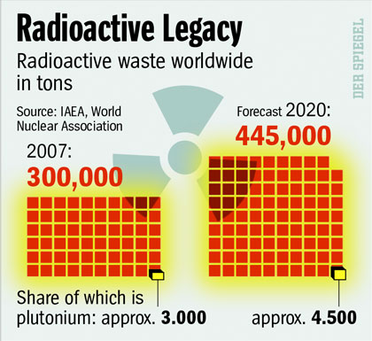
Climate change scientist and Australian of the Year Tim Flannery says
nuclear power should only be a last resort for tackling global warming.

The Federal Government is planning to lift bans on nuclear power and remove impediments to uranium mining and xports.

Dr Flannery says there are many undesirable attributes to nuclear power.

"I just think you take a three-fold approach, first let's get as [energy] efficient as we can, secondly use our local power sources, the
renewables - whether they be geothermal or wind - which we've got excellent sources of here in this country, of solar, and then if we
still have a deficit, yes we can look at nuclear power," he said.

http://www.abc.net.au/reslib/200702/r126015_411079.jpg

many undesirable attributes to nuclear power

Helen Caldicott says public awareness of the health risks posed by nuclear power has dropped off. She says nuclear power plants contribute substantially to climate change and expose humans to radiation-related illnesses.

Prominent environmentalist, Nobel Peace Prize nominee and paediatrician Dr Helen Caldicott says global warming and nuclear power plants will increase the spread of disease. The health risks posed by global warming and nuclear power are worse than those of smoking.

"Each reactor makes 200 kilograms of plutonium a year, whose half life is 240,000 years," she said.

"[It's] the most toxic substance known to the human race, such that a couple of kilos if adequately distributed could give everyone on earth cancer.

"So we're talking about a spread of disease that will make the tobacco industry look benign in terms of cancer."

"It's been known for several decades that as the earth heats there will be epidemics of malaria, particularly in places that are now cool like Melbourne and Seattle," she said.

"Diseases spread by arthropods like mosquitos and the like that will breed in the hot climates that normally are cool."
Monday, April 16, 2007. 4:14pm (AEST) http://www.abc.net.au/reslib/200607/r93551_280891.jpg

B1d_x1

